ANC Services Dashboard Ops Implementation

RMA Tracker: (Internal)
- Toggle On and Off Depending Contracts
RMA Tracker Fields
- Description
- Model #
- Project Code
- Shipping Method
- Shipment Tracking
- Amount
- Date Received
- Remit to Stock
- Repair Vendor
- Submission Contact
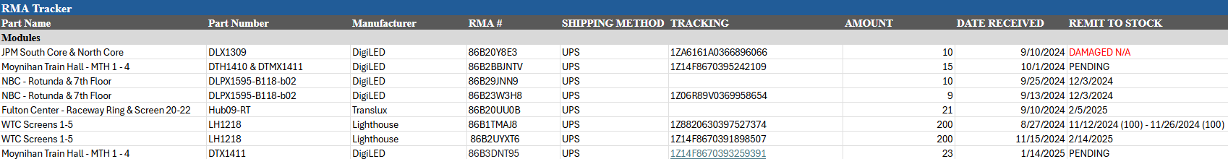

RMA Submission Link – (Internal or External)
- Toggle On and Off Depending Contracts
Submission Fields
- Company/Venue Name
- Client Name
- Client Phone
- Client Email
- Parts Details
- Quantities
- Part Number
- Photos
- LED Manufacturer
Once this form is completed and submitted this will create a ticket and be listed under a tracker or queue list.

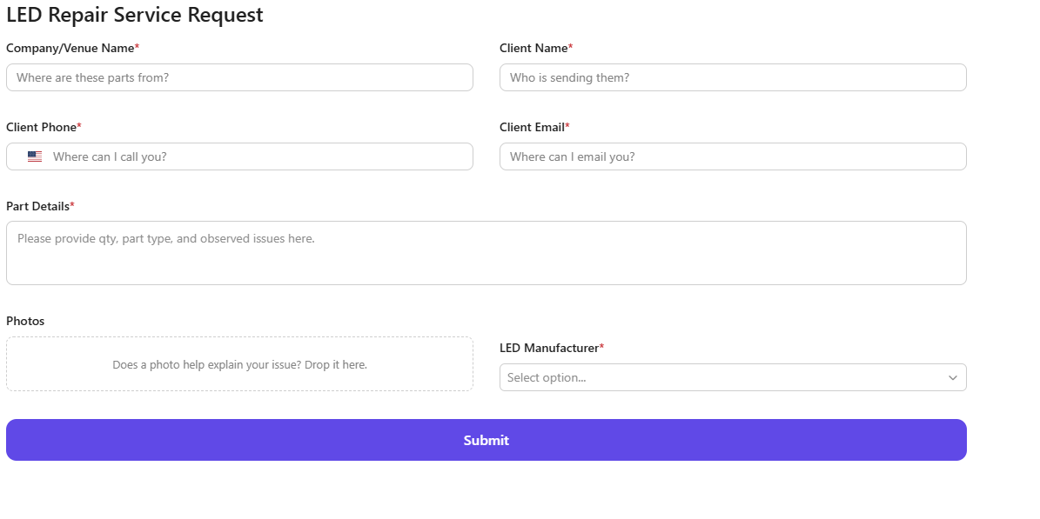

Maintenance Logs: (Internal)
- Toggle On and Off Depending Contracts
Maintenance Log Fields
- Issue
- Issue Summary
- Location Reported
- Reported Date
- Last Updated
- Details to Resolve
If this could somehow roll up into the Venue Profile so we could track data on how many times we have people going in to do maintenance. Can track exact components being changed to forecast long term parts inventory. Can show value to clients on the work being completed for our service contracts.
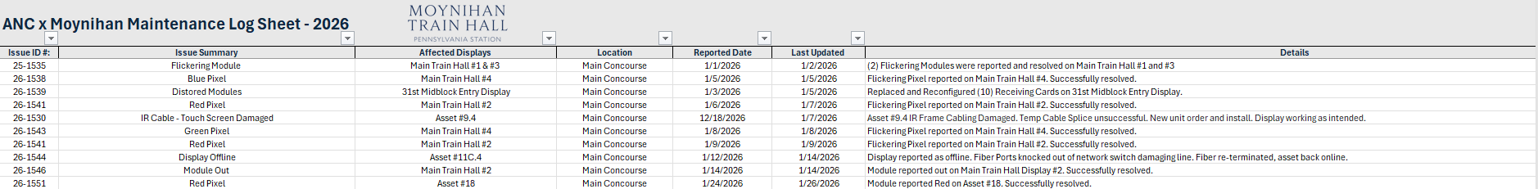

Inventory – (Internal)
- Toggle On and Off Depending Contracts
Inventory
- Part Name
- Part Number
- Project Code
- Manufacturer
- Location Room # if applicable
- Screen Location
- Amount
